Pet Care Services on Demand: A Mobile App for Scheduling Veterinary and Grooming Services
*Note: Sub-titles are not captured in Xplore and should not be used

Andrew Surya Prartama
Digital Business Innovation Department, Binus Business School
Bina Nusantara University
Bandung Campus
Jakarta, Indonesia andrew.pratama@binus.ac.id
Victor Lim Putra
Digital Business Innovation Department, Binus Business School
Bina Nusantara University
Bandung Campus
Jakarta, Indonesia
victor.putra@binus.ac.id

Marcello Setiawan
Digital Business Innovation Department, Binus Business School
Bina Nusantara University
Bandung Campus
Jakarta, Indonesia
marcello.setiawan@binus.ac.id

Ikrar Adinata Arin
Information System Department,
School of Information Systems
Bina Nusantara University
Jakarta, Indonesia
ikrar@binus.ac.id

Novandio Zevanya Kurnia
Digital Business Innovation Department, Binus Business School
Bina Nusantara University
Bandung Campus
Jakarta, Indonesia
novandio.kurnia@binus@ac.id

Abstract— The increasing demand for pet care services, such as grooming and veterinary consultations, has exposed inefficiencies in traditional manual booking processes. This paper presents a solution in the form of a mobile application designed to streamline these services through a comprehensive on-demand platform. Utilizing the Double Diamond method, this research emphasizes user-centered design to integrate key features like automated scheduling, digital payments, and real-time notifications. Through literature review and analysis, we identify current gaps in existing systems and propose an integrated solution that enhances user experience and operational efficiency for service providers. The proposed application not only supports digital transformation in the pet care industry but also offers a practical and scalable model for future service development. Projections show that this solution is both feasible and timely, aligning with the ongoing technological revolution in the digital service economy.
Keyword— pet care, mobile app, scheduling system, grooming, veterinary service, digital transformation

Introduction
The bond between humans and their pets in the current day has grown and evolved significantly, the increase of pet ownership and their regard to their companion make veterinary become one of the important services for most pet owners [1]. Grooming sessions are essential to ensure the health and wellbeing of a pet besides that veterinary can provide necessary treatment for the animal companion in urgent situations [2]. But due to high demand and complicated process often make veterinary become a challenge for pet owner especially in booking and scheduling session for grooming this problem introduces a gap in this industry which is efficiency [3], [4].
In the modern era, efficiency is one of the most important things everyone demands this paper explore those gap and opportunity and introduce pet service on demand [5]. A mobile app application designed to make scheduling of veterinary and grooming session easy and efficient [6], [7]. This app serves as a solution to streamline the booking and scheduling process, eliminating the common challenges faced by pet owners when trying to secure veterinary or grooming services [3], [8]. By providing a more accessible and hassle-free experience, it ensures that pet owners can easily manage their pet’s health and well-being the frustration of long wait or complex procedures [9], [10], [11].
Beyond the technical framework, this study explores the potential of pet service on demand implication in enhancing the efficiency of veterinary service, it’s projected the growing trend of digital transformation in the pet industry will reach $358 billion by 2027 [12]. Through this exploration we aim to contribute insights into the role of mobile technology to reshape the process of per care and fostering a future where quality pet care can be accessible and effortless for pet owners worldwide [13], [14]. Due to these conditions, the purpose of the current research is to develop a business model for a web-based pet service platform, which can help pet owners and service providers conduct transactions more efficiently and effectively.

Preview Research
We conducted a simple literature review covering the development of mobile pet service apps in Indonesia over the past ten years. Our goal was to understand the role of mobile pet service apps in ensuring convenience and ease in pet service booking services. We achieved this by analyzing and compiling relevant research from databases such as Google Scholar and Scopus, and using an AI-based academic tool, Publish or Perish. Through this method, we identified significant developments, emerging trends, and gaps in the literature, providing a strong foundation for our exploration of how pet service apps contribute to increasing convenience and ease in the pet service industry in Indonesia.
Based on previous research by Satoh and colleagues; in developing pet health applications it is crucial to incorporate a comprehensive feature model that prioritizes robust appointment scheduling and secure payment systems [15]. The IJCS study reveals that while current pet health apps offer functionalities such as user and pet profile management, appointment recording, and consultation services, their limited focus on real-time scheduling and efficient transaction processing contributes to low user adoption [16]. This finding emphasizes that application design must ensure ease of access, responsiveness, and the integration of automated notifications and secure online payments—capabilities that significantly enhance user experience over conventional manual booking methods [17].[18]
Fajar Dwi Cahyo and colleagues, in developing a pet clinic application, it is important to prioritize the integration of the Midtrans payment gateway, veritrans or midtrans is a payment gateway that helps e-commerce (online shops) in Indonesia to accept payments from customers quickly and easily [19]. Payment Gateway is also an infrastructure component that plays an important role in ensuring transactions take place without problems and are totally protected through the internet network [20]. Which contributes to the ease and security of online transactions and improving user experience [21]. This finding emphasizes that application design must pay attention to ease of access, responsiveness, and the ability to convey service information more effectively than using social media such as WhatsApp. In addition, the use of mobile technology integrated with an automatic payment system is also key to increasing user satisfaction and clinic operations [22]. Support for features such as service schedules and safe and efficient payments is essential to the success of this application [23], [24].
Furthermore, insights from Lim Chun Keat in the report reveal that the proposed solution goes beyond simple appointment scheduling by offering an integrated platform that tackles several user challenges concurrently [25]. The report emphasizes that the effectiveness of e-pet service applications depends on the smooth amalgamation of multiple service options, immediate booking confirmations, and a robust verification process for service providers [26]. Additionally, it stresses the necessity of incorporating dynamic notification systems and secure online payment gateways to effectively reduce issues like no-shows and last-minute cancellations [27]. Continuous user feedback and iterative testing are identified as critical factors in refining the user interface and enhancing overall system responsiveness [25][28].
Soleh O. and Wuryani R. analysed service challenges in Tangerang City pet shops, including limited promotions, manual processes, and difficulties in finding nearby shops. Their study examined a pet shop’s operational system, highlighting the need for a technology-driven solution to enhance efficiency in pet shopping, grooming, and daycare services [29]. The following is the system flow of a pet shop in Tangerang City.
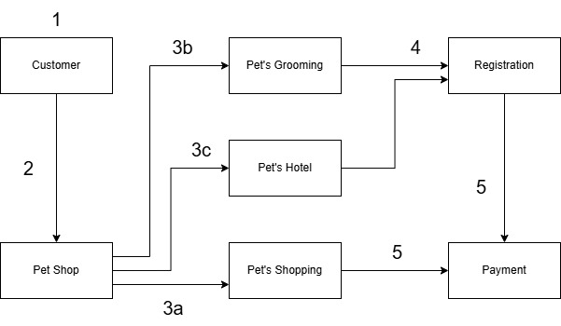
FIGURE I. Current System
Explanation of figure 1 above:
- Pet owners (Customer) looking for information about Pet Shop.
- Pet owners (Customer) comes to Pet Shop.
- Pet Shop provides 3 types of services that can be selected include:
- Pet's Shopping: Customers can shop for pets.
- Pet's Grooming: Customers can choose grooming service for their pets.
- Pet's Hotel: Customers can leave their pets.
- If you want to use the services of Pet's Grooming and Pet's Hotel then the customer must register first.
- Customers make payments at the checkout [30].

Research Methodology
Based on several related works, we try to apply the Double Diamond method by Design Council UK.
Double Diamond method is a design framework that guides teams in identifying key problems and building practical solutions step-by-step. It follows four main stages: Discover, Define, Develop, and Deliver [31], [32], [33].
Table I. The Research Stage of Double Diamond Method
Double Diamond Step | Description | Output
- Discover  [34]  - Defines  - Develop  - Deliver  [35] | In this stage, the researcher gather insights to see the problem from different angles  The researcher must shape a clear problem statement from this information  In this stage, the researcher must brainstorm and test our different solutions  Finally, the researcher must choose the most effective solution and put it into action | Use Case  Data Flow, ERD  Class Diagram, Sequence Diagram, Wireframe  Design

Analysis and Result
This paper discusses the development of a Pet Care Services on Demand mobile application that aims to simplify the process of ordering pet care services and veterinary consultations. This application is presented as a solution to the problem of inefficient manual ordering, by integrating features such as automatic scheduling, notifications, and digital payment systems. This study uses the Double Diamond method to design a solution that is centered on user needs and supports digital transformation in the pet service industry. With this approach, the application not only improves service efficiency but also provides a more practical, safe, and accessible user experience for pet owners in today's digital era. It is hoped that this solution can be a model for the development of similar services in the animal health and care sector more broadly in the future.

Use Case Diagram
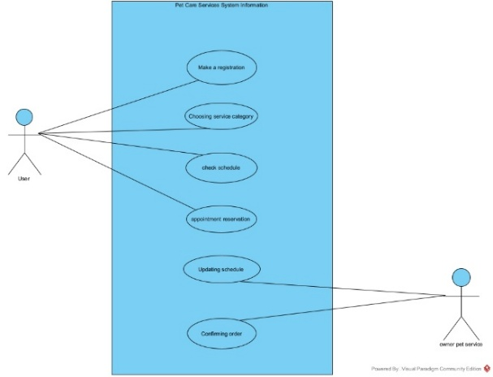
FIGURE II. Use Case Diagram
The use case diagram above illustrates the interaction between two main actors, namely the User (service user) and the Pet Service Owner (service owner). Users can perform several main activities in the system, such as making a registration, choosing a service category, checking the service schedule, and making an appointment reservation. In addition, users can also receive schedule updates and confirm orders. On the other hand, the pet service owner is responsible for the process of updating the schedule and confirming orders made by the user. This diagram shows a clear and structured interaction flow in the mobile-based pet care service application system.

Domain Model Class Diagram
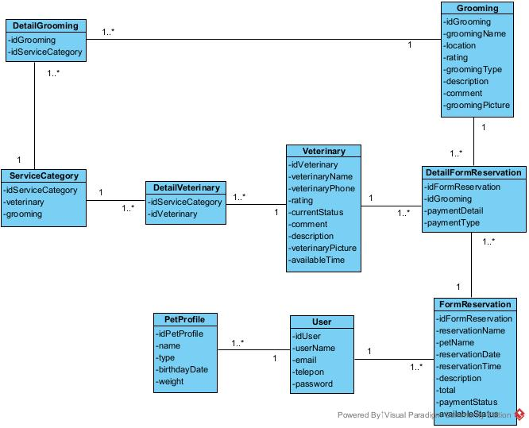
FIGURE III. Domain Model Class Diagram
This figure represents the data structure of a web-based pet service system that includes grooming and veterinary services. Core entities such as User, Pet Profile, Form Reservation, Veterinary, Grooming, and Service Category are used to manage the flow of information. Users can create pet profiles and make reservations for services, which are linked to specific categories and payment details. Each service, whether grooming or veterinary, contains essential information like name, location, rating, description, and available time slots. This structured system is designed to streamline and simplify the pet care booking process, ensuring a more efficient and user-friendly experience.

Mockup design
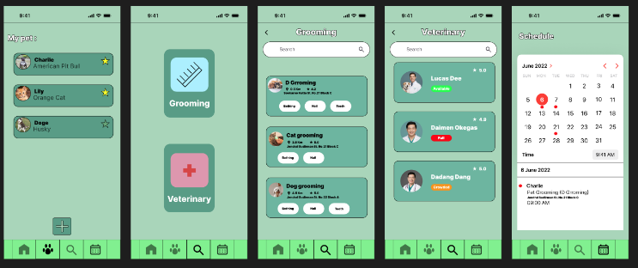
FIGURE IV. Mockup Design
This figure represents the Mockup design of pet service system that includes grooming and veterinary services. Core entities such as User, Pet Profile, Form Reservation, Veterinary, Grooming, and Service Category are used to manage the flow of information. Users can create pet profiles and make reservations for services. Each service, whether grooming or veterinary, contains essential information like name, location, rating, description, and available time slots

Conclusion
This research demonstrates how technology can significantly enhance the efficiency of booking pet care services by integrating all service processes such as scheduling, notifications, and digital payments into a single, user-friendly mobile application. Developed using the Double Diamond methodology, the platform addresses common issues faced by pet owners and service providers, offering a streamlined and accessible solution. This research shows how technologies can improve efficiency in pet care service booking. Through a comprehensive on-demand platform and the use of the necessary methodology to present a solution that integrates all processes of pet care service into one compact application, it offers a practical solution for the future development of pet care services. Future projections support the effectiveness and readiness of this solution to be implemented in real-world contexts, especially amid ongoing technological advancements.

References
[1] E. Fauzi, M. Nurunnisa, R. Ah Al Adawiyah, and I. Artikel ABSTRAK, “Penerapan design thinking dalam pengembangan sistem informasi pet friend sebagai aplikasi petshop online berbasis android,” Oktober, vol. 4, no. 2, pp. 63–72.
[2] J. K. Lemuela, E. Chandra, J. Letjen, and S. Parman, “PERANCANGAN IDENTITAS VISUAL LAYANAN MOBILE GROOMING HI PETS Program Studi Desain Komunikasi Visual Fakultas Seni Rupa dan Desain Universitas Tarumanagara,” Jurnal Seni Rupa, vol. 12, no. 1, p. 11440, 2023.
[3] S. A. Azaliarahma, E. I. Martyan, A. Rahmadani, and R. T. Dirgahayu, “PENGEMBANGAN APLIKASI KONSULTASI ONLINE DAN JANJI TEMU DOKTER HEWAN BERBASIS ANDROID,” Jurnal Sains, Nalar, dan Aplikasi Teknologi Informasi, vol. 2, no. 1, Sep. 2022, doi: 10.20885/snati.v2i1.17.
[4] E. Yusriyanah and I. Prihandi, “Aplikasi E-Commerce Petshop Berbasis Web Dengan Metode Incremental (Studi Kasus Puri Vet Kembangan),” 2019. [Online]. Available: https://jurnal.ikhafi.or.id/index.php/jusibi/67
[5] G. Dowletova, A. Danglyyeva, and ..., “A PLATFORM FOR PET ADOPTION, PET CARE TIPS, AND VETERINARY SERVICES,” … И НАУКА В XXI ВЕКЕ, 2025, [Online]. Available: https://mpcareer-google.ru/index.php/journal/article/view/753
[6] H. Sirajuddin and M. Rusdi, “Perancangan Aplikasi Pelayanan Pada Klinik Hewan Berbasis Web Menggunakan Model DEVOPS (Development Dan Operation),” Technologia: Jurnal Ilmiah, 2024, [Online]. Available: https://ojs.uniska-bjm.ac.id/index.php/JIT/article/view/14359
[7] F. KUSUMA, PENGEMBANGAN APLIKASI KONSULTASI HEWAN PELIHARAAN BERBASIS MOBILE ANDROID UNTUK KLINIK DOKTER HEWAN. repository.mercubuana.ac.id, 2022. [Online]. Available: https://repository.mercubuana.ac.id/76207/
[8] F. Jian, J. Tan, and Y. Bi, “Research on Pet Business Strategy and Service Design in Internet Economy Taking an APP Platform Development Project as an Example,” 2021.
[9] A. Ependi, “Perancangan Sistem Informasi Konsultasi Dokter Hewan, Pet Hotel Dan Pet Grooming Berbasis Web Dengan Metode Location Based Service,” 2023. [Online]. Available: http://bsti.ubd.ac.id/e-jurnal
[10] P. Penchalaiah, I. S. Akhil, A. V. J. Sai, C. H. Vardhan, C. Siddu, and ..., “Vet Care: Online Consulting Application,” indusedu.org, [Online]. Available: https://indusedu.org/pdfs/IJREISS/IJREISS_4232_78238.pdf
[11] E. Blancaflor, M. A. Agbayani, A. Guevarra, and ..., “VETGO: A Mobile Application Designed for Pet Veterinary Services,” Proceedings of the 2024 …, 2024, doi: 10.1145/3647782.3647806.
[12] Y. Feng, Digital Pet Product &Service Platforms The Diversity of the Industry. scholar.archive.org, 2022. [Online]. Available: https://scholar.archive.org/work/6f5ayz6hy5bc5mjaozjrx6msyy/access/wayback/https://www.atlantis-press.com/article/125971860.pdf
[13] Y. Wang and S. Al-Dubaee, “Exploring Digital Pet Care: The Development and Implementation of a Cat-Sitting Web Application,” in 2023 3rd International Conference on Electronic Information Engineering and Computer Science, EIECS 2023, Institute of Electrical and Electronics Engineers Inc., 2023, pp. 1280–1284. doi: 10.1109/EIECS59936.2023.10435533.
[14] G. Ai Leen, S. Anjum Shaik, and C. Thong Chee Ling, “A Development of a Prototype based Mobile Pet Care Application.”
[15] A. M. Abu-Seida, A. Abdulkarim, and M. H. Hassan, “Veterinary telemedicine: A new era for animal welfare,” 2024, Faculty of Veterinary Medicine, University of Tripoli. doi: 10.5455/OVJ.2024.v14.i4.2.
[16] P. B. Bök and D. Micucci, “The future of human and animal digital health platforms,” J Reliab Intell Environ, Sep. 2024, doi: 10.1007/s40860-024-00232-0.
[17] A. N. A. D. Satoh, E. K. Budiardjo, and K. Mahatma, “Feature Model for Pet Health Application Domain using Feature Oriented Domain Analysis,” The Indonesian Journal of Computer Science, vol. 13, no. 4, Aug. 2024, doi: 10.33022/ijcs.v13i4.4296.
[18] D. C. López, L. G. Colca, L. Andrade-Arenas, and M. Cabanillas-Carbonell, “Design of a Mobile Application for the Control of Pet Care,” International Journal of Engineering Trends and Technology, vol. 71, no. 3, pp. 395–406, Mar. 2023, doi: 10.14445/22315381/IJETT-V71I3P242.
[19] Nawawi, “PENERAPAN PAYMENT GATEWAY MENGGUNAKAN MIDTRANS PADA WEBSITE PENYEWAAN ALAT OUTDOOR VERBENA ADVENTURE,” 2021.
[20] “3_185410088_BAB_II - Marcelina Nadur”.
[21] R. Hidayatulloh, “Pembangunan Aplikasi Mobile Toko Online Dan Booking Service Di Sentra Anugrah Motor Memanfaatkan Api Payment Gateway,” Universitas Komputer Indonesia, 2020.
[22] S. H. Hasibuan, M. Irwan, P. Nasution, S. Suci, and A. Sundari, “DEVELOPMENT OF PAYMENT GATEWAY DIGITALIZATION USING MIDTRANS IN THE USE OF HALODOC,” INTERNATIONAL JOURNAL ON ADVANCED TECHNOLOGY, ENGINEERING, AND INFORMATION SYSTEM (IJATEIS), vol. 2, no. 1, 2023, [Online]. Available: http://ojs.transpublika.com/index.php/IJATEIS
[23] F. D. Cahyo, S. D. Sancoko, and S. Diwandari, “Implementasi Layanan Payment Gateway Pada Aplikasi Klinik Hewan Peliharaan Berbasis Mobile,” Jurnal Teknologi Dan Sistem Informasi Bisnis, vol. 6, no. 1, pp. 84–94, Jan. 2024, doi: 10.47233/jteksis.v6i1.1098.
[24] D. Aditya Putra, G. Made Arya Sasmita, and Aak. Cahyawan Wiranatha, “E-Commerce Marketplace Petshop Menggunakan Integrasi Rajaongkir API dan iPaymu Payment Gateway API,” 2020.
[25] Lim Chun Keat, “E-pet Service Apps for Kampar Residential Mobile Application,” 2024. Accessed: Mar. 11, 2025. [Online]. Available: http://eprints.utar.edu.my/id/eprint/6880
[26] T. B. Samudra and A. Anggara, “Implementation of Android-Based Salon Booking Application for Customer Service Optimization,” International Journal Software Engineering and Computer Science (IJSECS), vol. 4, no. 3, pp. 1056–1065, Dec. 2024, doi: 10.35870/ijsecs.v4i3.3279.
[27] Y. J. Ru and H. Kamaludin, “Pet Care Management System,” Applied Information Technology And Computer Science, vol. 4, no. 2, pp. 2019–2038, 2023, doi: 10.30880/aitcs.2023.04.02.113.
[28] A. Tkalich, E. Klotins, T. Sporsem, V. Stray, N. B. Moe, and A. Barbala, “User feedback in continuous software engineering: revealing the state-of-practice,” Empir Softw Eng, vol. 30, no. 3, p. 79, Jun. 2025, doi: 10.1007/s10664-024-10557-2.
[29] J. K. P, H. S. V, and A. Professor, “Pet Management System,” 2025. [Online]. Available: www.ijcrt.org
[30] O. Soleh, “OPet’s is petshop mobile application to meet all the needs of pets (day-care, shopping and grooming): Development and business,” Proceedings - 2017 2nd International Conferences on Information Technology, Information Systems and Electrical Engineering, ICITISEE 2017, vol. 2018, pp. 141–146, 2017, doi: 10.1109/ICITISEE.2017.8285483.
[31] A. Daly-Smith et al., “Using a multi-stakeholder experience-based design process to co-develop the Creating Active Schools Framework,” International Journal of Behavioral Nutrition and Physical Activity, vol. 17, no. 1, Feb. 2020, doi: 10.1186/s12966-020-0917-z.
[32] M. Suoheimo, T. Turunen, and S. Miettinen, “The First Diamond is Service Design and the Second is UX/Interaction Design: the Double Diamond Model and Team Roles in Making a Mobile Service Application Using Cross-Disciplinar,” 2022. [Online]. Available: https://www.researchgate.net/publication/363336686
[33] H. P. Pandey, T. N. Maraseni, and A. A. Apan, “Enhancing systematic literature review adapting ‘double diamond approach,’” Heliyon, vol. 10, no. 22, Nov. 2024, doi: 10.1016/j.heliyon.2024.e40581.
[34] H. Oliver et al., “A longitudinal study combining the Double Diamond framework and Behavior Change Wheel to co-create a sedentary behavior intervention in police control rooms,” Journal of Public Health (United Kingdom), vol. 46, no. 3, pp. 419–429, Sep. 2024, doi: 10.1093/pubmed/fdae061.
[35] A. Farhantama and M. Miksa Mardhia, “Double Diamond Approach for Mobile-based UX: Connecting Students to Professional IT Projects,” Journal of Information Systems and Informatics, vol. 6, no. 2, 2024, [Online]. Available: http://journal-isi.org/index.php/isi

